273/2
GEOGRAPHY

PAPER 2
AUGUST, 2022
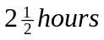

JINJA JOINT EXAMINATIONS BOARD

Uganda Certificate of Education

MOCK EXAMINATIONS – AUGUST, 2022

GEOGRAPHY

Paper 2

2 hours 30 minutes

INSTRUCTIONS TO CANDIDATES:

Answer four questions in all.
Choose two questions from part I and two from part II.
In part II, only one question should be chosen from any one region
Additional question(s) answered will not be marked.

PART I: THE REST OF AFRICA
Answer two questions in this part.
1 (a) Draw a sketch map of Africa and on it, mark and label:
- Latitudes: Capricorn, Equator and Cancer,
- Natural vegetation type: Montane, Mangrove and Savanna. (07 marks).
(b) Describe the characteristics of any one of the natural vegetation types given
in (a)(ii) above. (06 marks)
c) Explain the conditions which have led to the growth of the vegetation type
chosen in (b) above. (08 marks)
(d) Outline the effects resulting from the destruction of natural vegetation cover
in Africa. (04 marks)

2. Study table I below showing the number of people employed in the fishing sector for the
selected countries in Africa (2017) and answer the questions that follow:

Table I: Number of people working in the fishing sector (2017)
Country | No. of people employed in the fishing sector
South Africa | 1,472,621
Nigeria | 1,296,170
Gabon | 610,072
Senegal | 99,558
Morocco | 325,886

- Draw a bar graph to represent the information contained in the table I above. (07 marks)
- Identify the country which employed the:
- most dominant
- least dominant,
number of people in the fishing sector. (02 marks)
(c ) Describe giving specific examples, the conditions which have favoured the development of the fishing sector in any one country given in the table I above. (06 marks)
(d) (i) Explain the contribution of the fishing sector to the development of the country chosen in (a)
above. (06 marks)
(ii) Outline the steps being taken to promote the fishing sector in African countries. (04 marks)

3. (a) Study figure I below carefully showing the river Nile basin and answer the questions that follow:

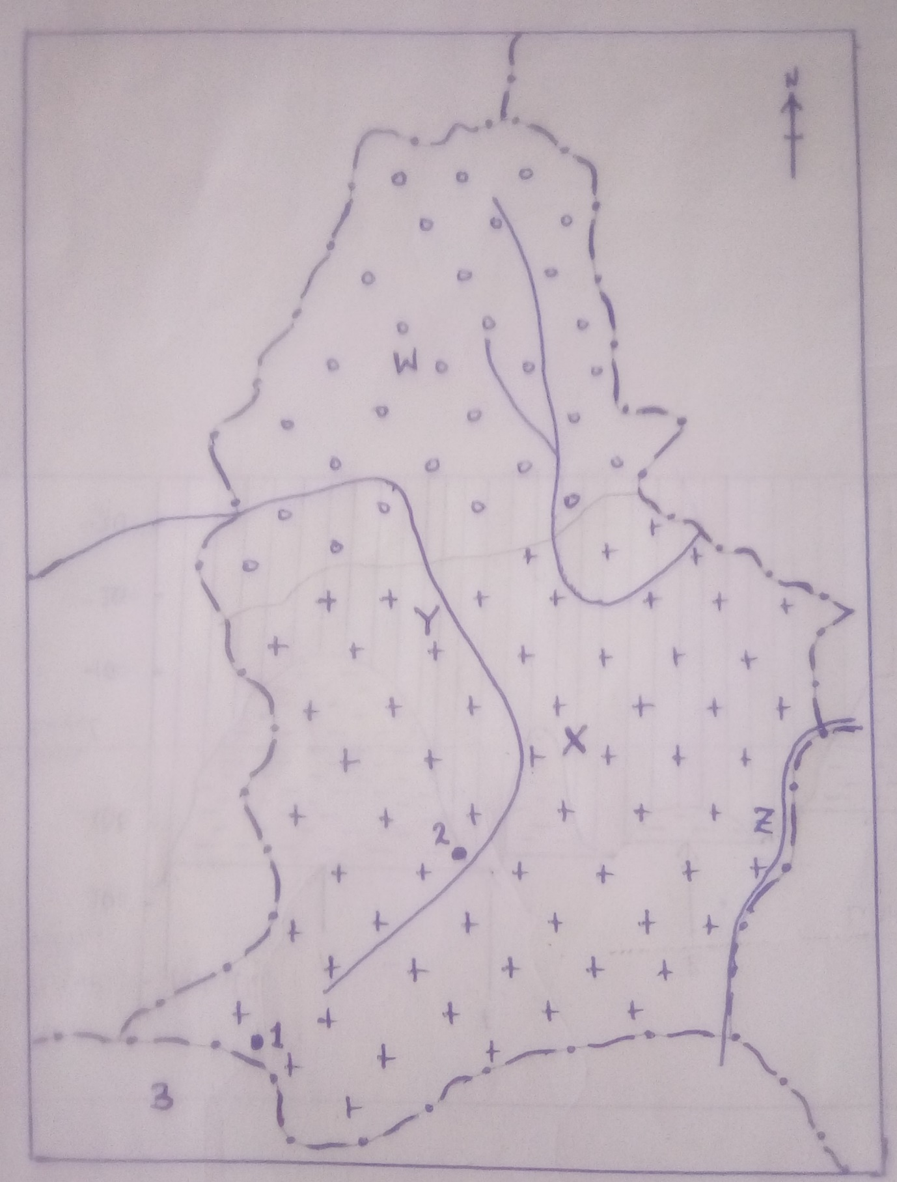

Name the:
- Towns marked 1,2 and 3
- Land forms A and B
- Irrigation scheme marked C.
- Lake marked D. (07 marks)
(b) Describe:
- with specific examples, the factors which have favoured the development of the
irrigation scheme named in (a) (iii) above. (06 marks)
- Any one method of irrigation used on the irrigation scheme named in (a)(iii) above.
(03 marks)
c) Explain the benefits of the irrigation scheme to the people living on the irrigation scheme
named at (a) (iii) above. (06 marks)
(d) Outline the problems resulting from the establishment of the irrigation schemes in Africa.
(04 marks).

4. study table II below showing Africa’s population growth between 1980 and 2030 (projected) and answer the questions that follow:

Table II: Africa’s population growth (1980-2030 projected)

Year | Population size (‘000)
1980 | 453,390
1990 | 616,411
2000 | 318,099
2010 | 1,133,508
2020 | 1,296,777
2030 | 1,524,645 (projected)

- Draw a line graph to show the information contained in the table above. (08 marks).
- (i) Describe the trend of Africa’s population growth between 1980 and 2030 (projected).
(ii)State the period in which Africa experienced the:
- highest,
- lowest
Percentage increase in population. (08 marks)
(c ) Explain with specific examples the factors which have led to the high population
growth rate in Africa. (06 marks)

PART II: STUDIES IN DEVELOPMENT
Answer two questions from this part.
REGION I: NORTH AMERICA

5. Study figure 2 below showing the cross section of the Great lakes and St. Lawrence Sea way, showing depth:

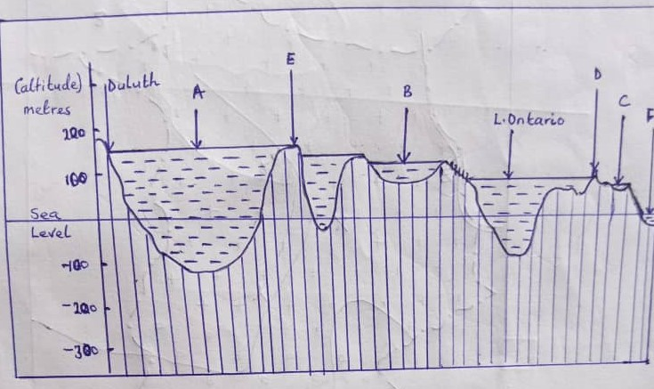

- Lakes A, B and C
- Features D and E
- Ocean F (06 marks).
- Describe:
(i) the aims of the construction of the Great lakes and the St. Lawrence Sea way.
ii) the operation of any one of the navigational locks along the St. Lawrence Sea way.
(10 marks).
- Explain the contribution of the St. Lawrence Sea way project to the development of USA and Canada. (06 marks)

- Outline the environmental problems resulting from the establishment of the St. Lawrence Sea way project. (03 marks).

6. Study the table III below showing cotton growing in selected states of southern USA and answer the questions that follow:

Table III: selected states of USA: cotton growing in selected states

States | Production (%) | Cotton Belt | Degrees
California | 25 | New cotton belt | -
Texas | 30 | New cotton belt | 108
Mississippi | 10 | Old cotton belt | -
New Mexico and Arizona | 10 | Old cotton belt | -
Others | 25 | Old cotton belt | -

- (i) Calculate the missing values to complete the table above.
- Name any one state with the least relative importance of cotton production in the old
cotton Belt in Southern USA. (03 marks)
- Draw a pie chart to show the relative importance of cotton growing in selected states of Southern USA. (06 marks)
- Explain using specific examples, the factors which led to the decline in the Old cotton Belt in Southern USA. (08 marks)
- Outline:
- the effects of cotton growing on the environment in the Southern USA.
- Measures that should be taken to solve the negative effects of cotton growing on the environment. (08 marks)

7. (a) Draw a sketch map of British Columbia and on it mark and name any two:
- rivers
- interior timber collecting centres
- coastal timber exporting ports
- Pacific Ocean. (07 marks)
(b) (i) State any two tree species found in British Columbia.
(ii) Describe the characteristics of the forests found in British Columbia. (06 marks)
(c) Explain, using specific examples the physical factors that have led to the development of
forestry industry in British Columbia. (08 marks)
(d) Outline the problems facing the forestry industry in British Columbia. (04 marks)

REGION II: THE RHINELANDS

8. Draw a sketch map of the Rhine Basin and on it mark and name:
- (i) rivers: Rhine, Neckar and Mosel,
(ii) countries Luxembourg and Germany.
(iii) Ports: Rotterdam, Mannheim and Basel, ( 09 marks)
- Describe with specific examples the conditions which favoured the development of Rotterdam (06 marks).
- Explain the contribution of port Rotterdam to the development of the Rhine basin.
(06 marks)
- Outline the problems resulting from the establishment of port Rotterdam. (04 marks)

9. Study Table IV : climate statistics of Lugano (Switzerland) and answer the questions that
follow:
Table IV : Climate statistics of Lugano, Switzerland at altitude(276m)

Month | J | F | M | A | M | J | J | A | S | O | N | D
Temp(ºC) | -2.3 | 3.6 | 2.3 | 11.3 | 15.5 | 19.4 | 21.3 | 20.8 | 17.5 | 12.3 | 7.1 | 3.2
Precipitation(mm) | 57 | 67 | 118 | 159 | 203 | 186 | 181 | 191 | 158 | 181 | 133 | 91

- Draw a suitable graph to show the climate of the station. (10 marks)

- Describe the characteristics of the climate of the station. (06 marks)

- Explain the influence of climate on the economic activities taking place in the area where the station is located. (06 marks)

- Outline the challenges faced by the people carrying out the economic activities in the area where the station is located. (03 marks)

10. Study figure III: Map of Luxemburg provided below and answer the questions that follow:
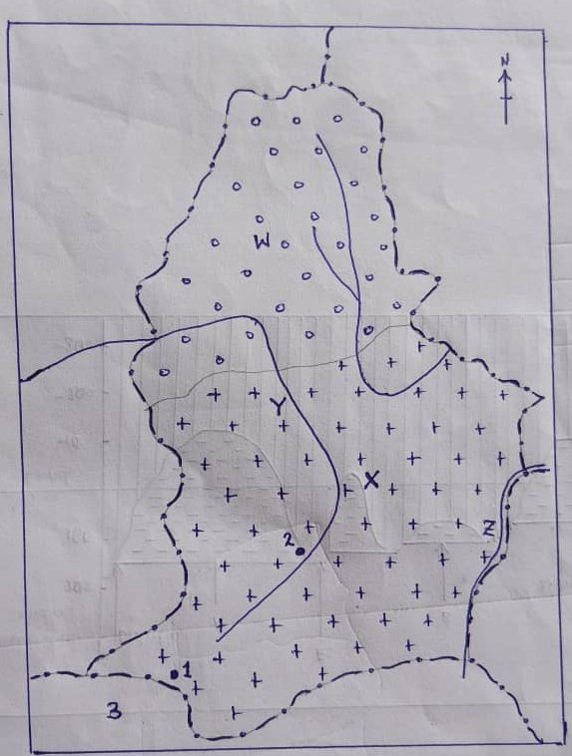

- Name the:
- physiographic regions marked W and X;
- rivers marked Y and Z;
- industrial towns marked 1 and 2;
- country marked 3 (07 marks)
- (i) State any one type of industry found in each industrial town named in (a) (iii).
ii) Describe with specific examples, the factors which have led to the development of
industries in Luxembourg. (08 marks)

- Explain the importance of the industrial sector to the development of Luxembourg.
(06 marks).
- Outline the effects of the industrial sector on the environment in Luxembourg. (04 marks)

REGION III: CHINA

11. (a) Draw a sketch map of China and on it, mark and name the:
- rivers; Si-Kiang, Yangtze and Hwang-Ho,
- Yellow sea
- Tai
- Towns: Beijing (Peking), Wunan and Shanghai (09 marks)
- Describe the steps being taken to develop the Si-Kiang River basin. (06 marks)
- Explain the contribution of the Si-kiang River basin to the development of China.
(06 marks)
- Outline the effects of agriculture on the environment of in the Si-kiang River basin.
(04 marks)

12. Study figure IV: Map showing the location of Peking (Beijing) provided below and answer the questions that follow:
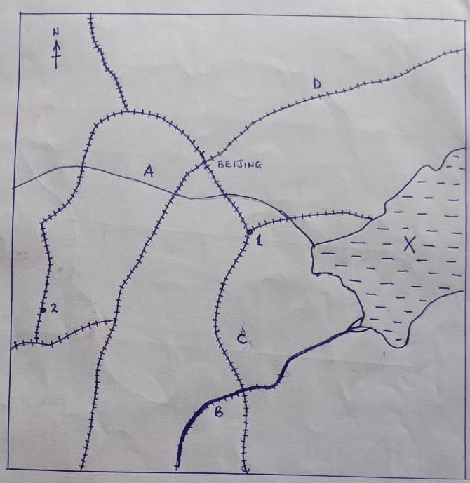

- Name the:
- rivers marked A and B,
- gulf marked X,
- towns marked 1 and 2,
- railway lines marked C and D. (07 marks)
- Describe the conditions which led to the growth of Beijing as an urban Centre.
(06 marks).
- State the functions of Beijing city. (04 marks)

- (i) Explain the problems faced by Beijing city.
- Outline the steps being taken to solve the problems in (d)(i) above. (08 marks)

13. Study table V below showing annual copper production and consumption in China
(2010- 2025) and answer the questions that follow:

Table V China: Annual copper production and consumption (‘000 metric tonnes)

Year | Copper ore production | Copper consumption
2010 | 68,072 | 120,394
2015 | 38,009 | 140,354
2020 | 167,933 | 193,471
2025 | 234,660 (projected) | 222,771 (projected)

- Draw a combined line graph to show annual copper production and consumption in China
between 2010 and 2025 (projected) (10 marks)

- Describe the:
- trend of production.
- trend of consumption,
- relationship between production and consumption of copper ore in China between 2010 and 2025 (06 marks)

- For any one area where copper ore is mined in China explain the factors which favoured
its production. (05 marks)

- Outline the contribution of copper ore mining to the development of China. (04 marks)

